Associate & Analyst Program

Survey Results

In September and October 2000, many of you participated in focus groups or a survey conducted at the request of the Associate & Analyst Program management. The purpose of obtaining the feedback was to gain a better understanding of the strengths, concerns and overall effectiveness of the Associate & Analyst Program. I want to thank each of you for your participation and apologize for the delay in sharing the results.

Consultants in the Organization Development department of Corporate Human Resources facilitated the focus groups, which concentrated on the PRC process. One hundred and fifty individuals were invited to participate in the focus groups. Watson Wyatt & Co. an independent consulting firm conducted the survey. The survey focused on the PRC process, the recruiting process, rotation management, Human Resources and the Program generally. The survey was sent to over 1,000 individuals. Associates, Analysts, HR Reps, PRC Reps, managing supervisors and executive leads for the recruiting teams were participants in the focus groups and the survey. Fourteen percent of Management (HR Reps, PRC Reps, Managing Supervisors, and Executive Leads) responded and 38% of the Associates & Analysts responded.

The feedback about the PRC that was obtained from the focus groups was essentially the same as that conveyed by the survey. Therefore, we have combined the common issues for this section. Based upon your feedback, the Program can improve in several areas; however, the over-riding theme in both the focus groups and the survey was regarding communication or the lack thereof. It covered communication about the processes, communication between Program management and the Associate & Analyst pool, and communication about changes in the Program. We intend to use the results of the current survey as the baseline and to conduct a survey annually in order to measure the level of improvement.

Although we did not share the results in as timely a manner as I would have liked, we were able to utilize the feedback to make changes in the PRC process prior to the year-end PRC as well as other changes that are outlined in the following section. We will continue to use the feedback to enhance the Program and improve the level of satisfaction among the Associate and Analyst Program participants and other individuals who utilize the Program.

The results are presented graphically. Following the graphs are the most common issues raised and actions that have been taken as well as those that will be taken in response to the feedback.

I sincerely appreciate the constructive feedback and believe it provides Program management an opportunity to work closely with both the managers and the pool participants to take the Program to the next level. Again, I thank you for your participation and your patience. If you have any additional feedback or comments please submit them to the website at http://axis.enron.com/.

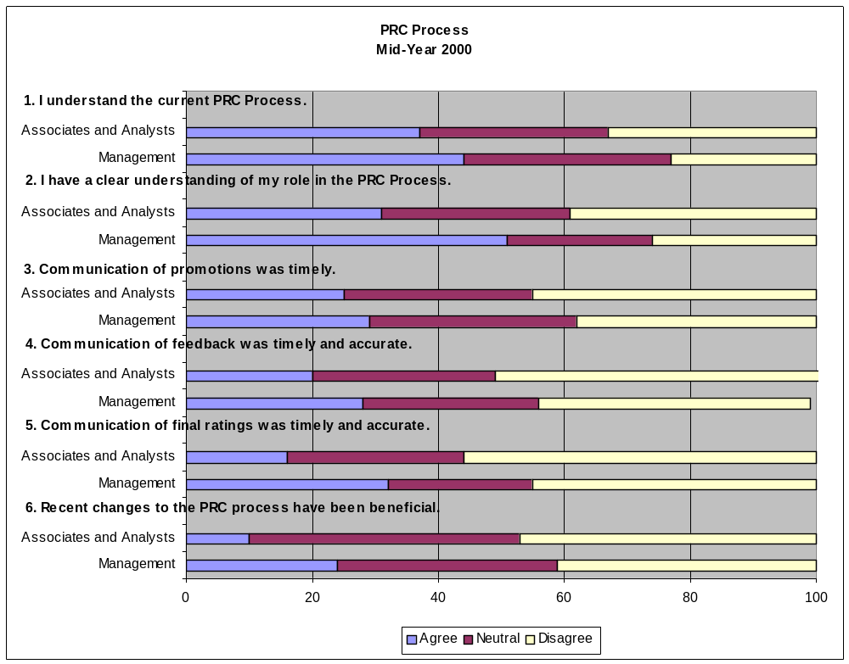

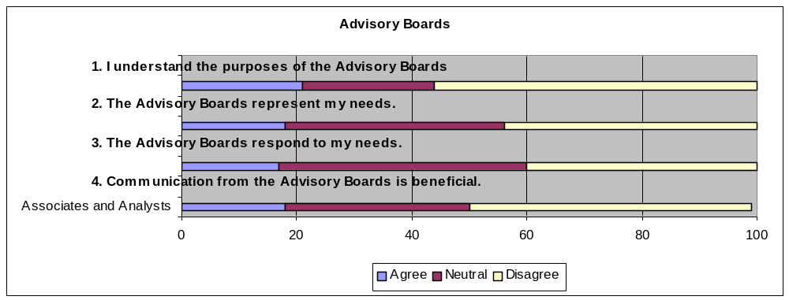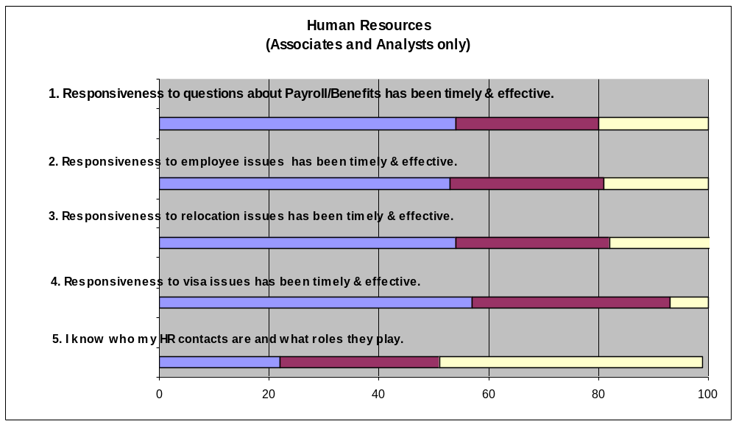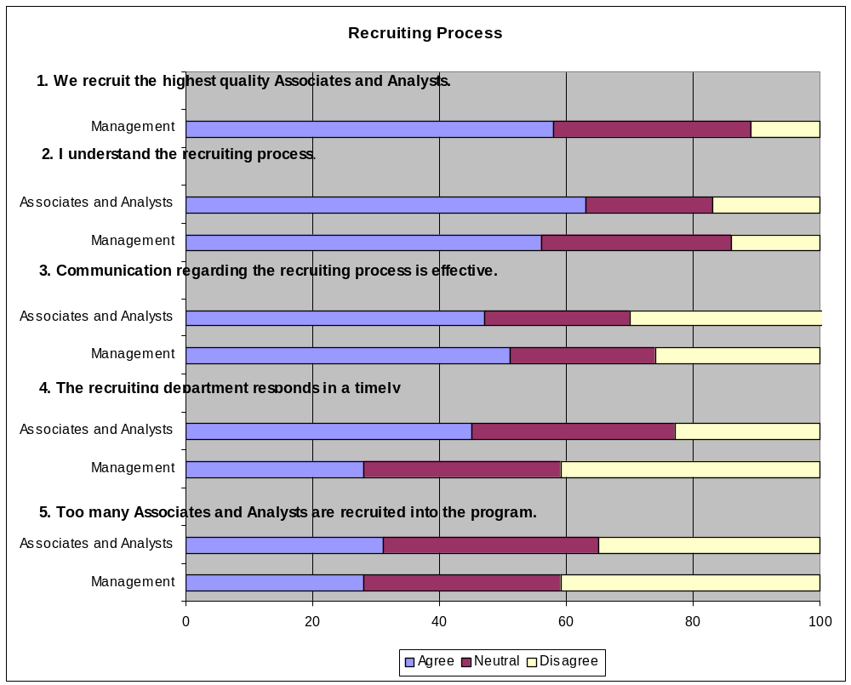

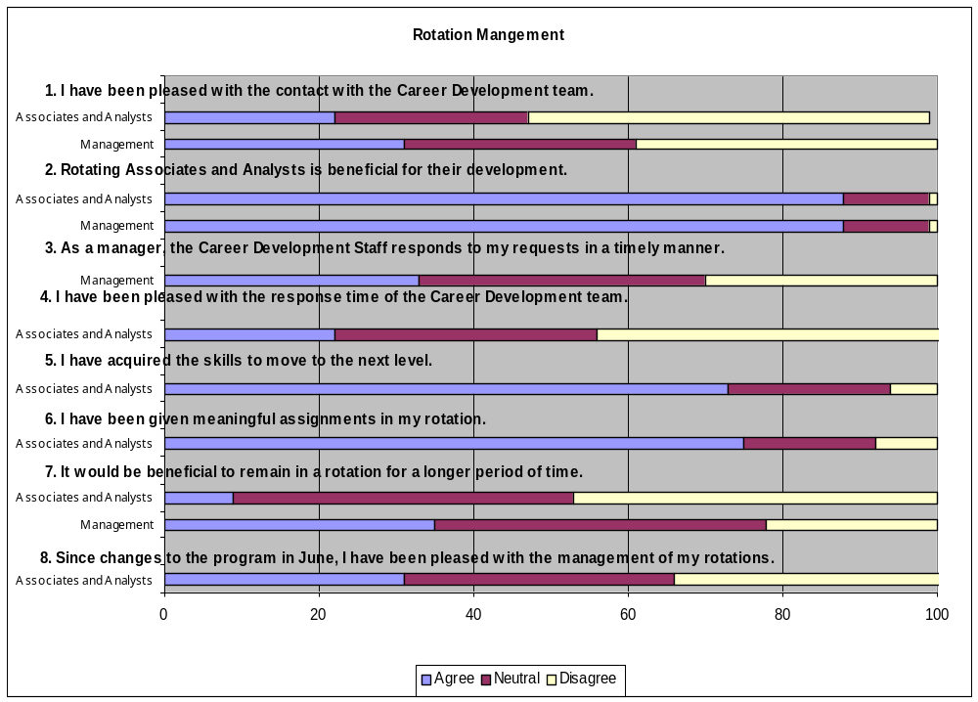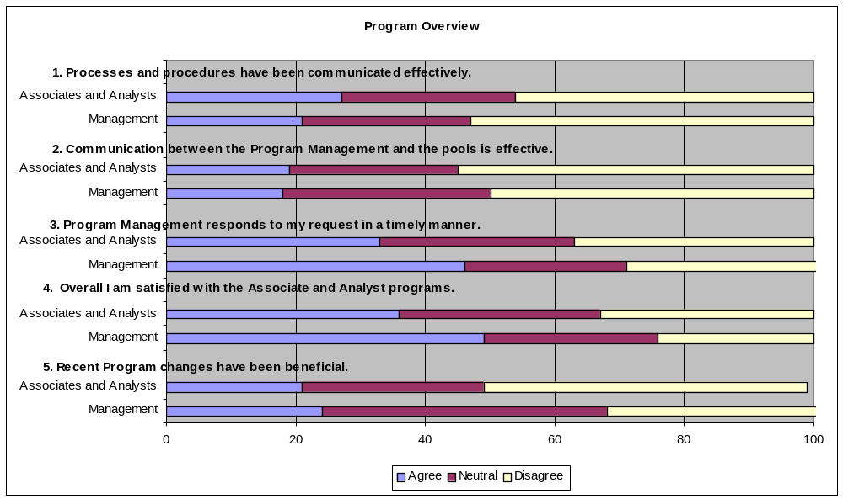
Common Issues and Actions

PRC Process
Issues
- Poor communication regarding the rationale, process, roles and responsibilities and the promotion guidelines
- Lack of understanding about the preferred distribution
- Lack of adequate and/or timely feedback and ratings from managers and PRC Reps
- Managers need training in providing effective feedback
- Too many Associates or Analysts assigned to each PRC Rep
- Job bias does not allow fair comparisons

Actions
- In November, Program Management held an enfo-session for Associates & Analysts to provide information about the PRC process and the preferred distribution
- In November, Jeff Skilling held a breakfast meeting for PRC Reps to reiterate the importance of the PRC process and explain their roles and responsibilities
- A memo describing the PRC process, roles & responsibilities and promotion guidelines was distributed to Associates, Analysts, HR Reps, PRC Reps and managing supervisors
- The PRC memo has been placed on the web-site and will be updated 60 days before each PRC meeting
- A timeline outlining the significant dates regarding the PRC was distributed to Associates, Analysts, HR Reps, PRC Reps and managing supervisors
- The timeline has been placed on the web-site and will be updated 60 days before each PRC meeting
- In December and January, training classes were offered by Corporate HR to assist managers in providing performance feedback
- In January 2001, Jeff Skilling held an enfo-session to discuss the Program and the rationale for the PRC. Associates, Analysts and managing supervisors were invited
- Program Management has provided the head of each business unit and their respective HR Rep a listing of Associates and Analysts who have not received written feedback
- The number of Associates and Analysts represented by each PRC Rep will be limited to 10 individuals
- PRC Reps have been instructed to focus on individual performance within a position rather than the position itself

Human Resources
Issues
- Respond in a more timely manner
- Confusion about responsibilities of Program HR Reps and the HR Reps in the business units
- Not sure who the Program HR Rep is
- Need better explanation of benefits

Actions
- Hired an additional representative to assist with responding to questions and concerns
- Will include a section on the website about HR’s role and contact information
- Began introducing the Program’s HR team at the orientation
- Will schedule an enfo-session during the second quarter to introduce the HR and Career Development teams to current pool members. Will explain roles and answer questions about rotations and benefits

Recruiting
Issues
- Recruiting needs to be a priority for the company and more senior professionals need to be involved
- Need to coordinate staffing needs with business units prior to setting hiring goals
- The Program hires too many Associates and Analysts
- Interviewers should be better trained

Actions
- Will conduct an analysis at the end of the fall recruiting season that will assess overall effectiveness, i.e. cost per hire, acceptance rates, core school selections, etc.
- Currently meeting with executive leads for all schools to debrief about the fall recruiting process and results and to obtain information about process improvements
- Working with business units to more closely align business needs with hiring goals
- Involved many more senior professionals in the process than were involved in the past. For example, Dave Delainey, Kevin Hannon, Jeff Shankman, John Lavorato and Rick Causey facilitated the Super Saturday decision-making meetings. Managers through managing directors conducted on-campus interviews
- Provided interviewer training in Houston and Portland for individuals involved in the recruiting process (approximately 400 people attended)

Rotation Management
Issues
- Purpose of Career Development department is unclear
- Rotations should not be dictated
- The timeframe for rotations should be reviewed
- Increase communication of rotational opportunities

Actions
- Will include a section on the website about Career Development’s role and contact information
- Began introducing the Career Development team at the orientation
- Will schedule an enfo-session during the second quarter to introduce the HR and Career Development teams to current pool members. Will explain roles and answer questions about rotations and benefits
- Will continue to evaluate how to provide “choice in rotations” while also meeting the needs of the business
- Established mid and year-end rotation evaluations for Associates and Analysts to obtain feedback on rotations

Overall Program
Issues
- Communication is not effective
- Would like more social events
- The Program should have greater involvement from the business units
- Would like to see an effective mentoring program
- Would like more training and development for Associates and Analysts
- The Program should be more flexible

Actions
- Program management is attempting to improve communications by utilizing several methods of communications, i.e. Enfo-sessions, the surveys and focus groups, written communications, web-site and e-speak
- Enfo-session re: PRC – 11/01/00; re: Program and PRC with Jeff Skilling – 1/13/01;
- Web-site has been updated with the most current contact information. Information about Program policies will be added by March 15, 2001 (i.e. graduate school loan program, etc.)
- A Program “open-house” is scheduled for the second quarter. This will provide members of the pool an opportunity to meet the entire Program staff
- The responsiveness of all members of the Program staff has been addressed. Individuals have been asked to respond to e-mails and voice-mails as soon as reasonably possible and under no circumstances more than 48 hours after receipt. If they are out of the office, they have been instructed to utilize the out-of-the-office function on the e-mail and voice-mail
- Members of the Program staff are working with the Advisory Board to schedule enfo-sessions and networking events
- Program management has recommended that a small committee of business unit heads oversee the Program
- The Program has tried several different mentoring programs, none of which have been effective. We are open to suggestions on how to create a mentoring program that is effective and utilized by the participants. Please send suggestions to the web-site at http://axis.enron.com/.
- The new 3-week orientation provides extensive training for new Associates and Analysts. We will be evaluating other possible training that could be provided to the rest of the pool on an on-going basis. Again we welcome suggestions

